**Design and Implementation of a Simple Networking Project #1**

**Project #1 Case Study and Requirements**

Design a network in Cisco Packet Tracer to connects ACCOUNTS and DELIVERY departments through the following:

* Each department should contain at least two PCs.
* Appropriate number of switches and routers should be used in the network.
* Using the given network 192.168.40.0, all interfaces sould be configured with correct IP addresses, subnet mask and gateways.
* All devices in the network should be connected using appropriate cables.
* Test communication between devices in both ACCOUNTS and DELIVERY departments.

**Technologies Implemented**

1. Creating a Simple Network using a Router and Access Layer Switch.
2. Connecting Networking devices with Correct cabling.
3. Connecting two Networks using a Router.
4. Subnetting and IP Addressing.
5. Assigning IP Addresses to Router's interfaces.
6. Static IP Address allocation to Host Devices.
7. Test and Verifying Network Communication.

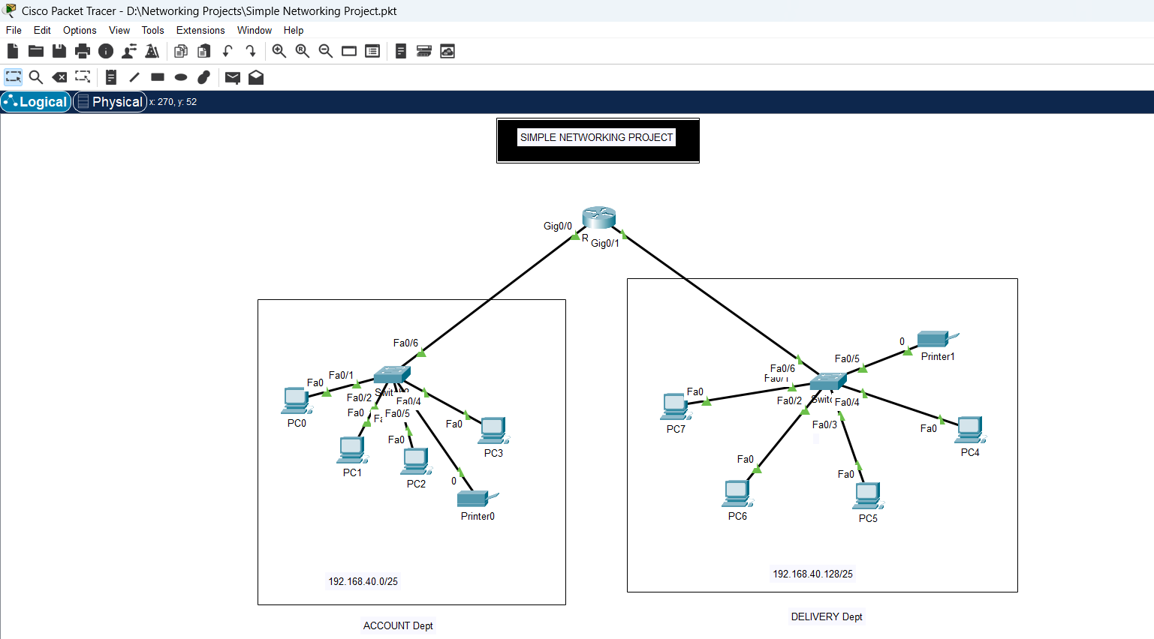

**Design and Implementation of a Small Office Home Office Network -SOHO Project#2**

**Project #2 Case Study and Requirements**

XYZ company is a fast-growing company in Eastern Australia with more than 2 million customers globally. The company deals with selling and buying of food items, which are basically operated from the headquarters. The company is intending to open a branch near the local village Bonalbo. Thus, the company requires young IT graduates to design the network for the branch. The network is intended to operate separately from the HQ network. Being a small network, the company has the following requirements during implementation;

* One router and one switch to be used (all CISCO products).
* 3 departments (Admin/IT, Finance/HR and Customer service/Reception).
* Each department is required to be in different VIANS.
* Each department is required to have a wireless network for the users.
* Host devices in the network are required to obtain IPv4 address automatically.
* Devices in all the departments are required to communicate with each other.

Assume the ISP gave out a base network of 192.168.1.0, you as the young network engineer who has been hired, design and implement a network considering the above requirements.   
  
**Technologies Implemented**

1. Creating a Simple Network using a Router and Access Layer Switch.
2. Connecting Networking devices with Correct cabling.
3. Creating VLANs and assigning ports VLAN numbers.
4. Subnetting and IP Addressing.
5. Configuring Inter-VLAN Routing (Router on a stick).
6. Configuring DHCP Server (Router as the DHCP Server).
7. Configuring WLAN or wireless network (Cisco Access Point).
8. Host Device Configurations.
9. Test and Verifying Network Communication.

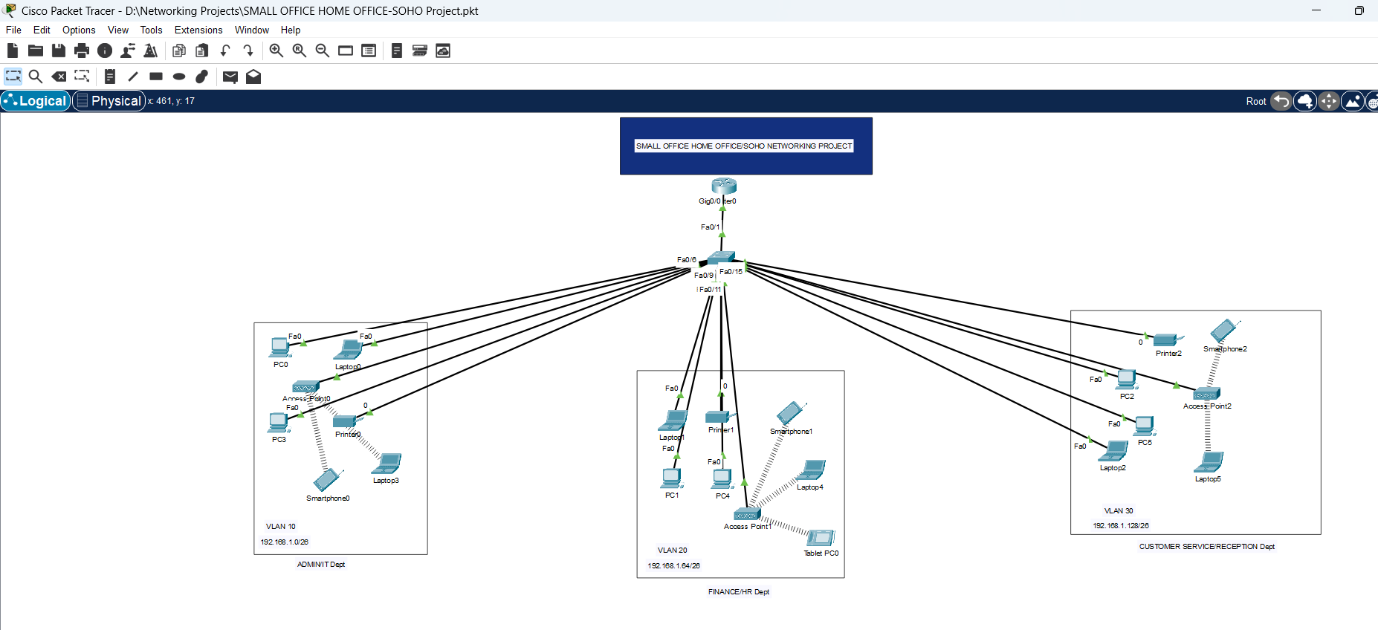

**Design and Implementation of an Hotel System Network Design Project #3**

**Project #3 Case Study and Requirements**

As a part of your end year networking project, you are required to design and implement Vic Modern Hotel network. The hotel has three floors; in the first floor there three departments (Reception, store and Logistics), in the second floor there are three departments (Finance, HR and Sales/Marketing), while the third floor hosts the IT and Admin. Therefore, the following are part of the considerations during the design and implementation;

* There should be three routers connecting each floor (all placed in the server room in IT department).
* All routers should be connected to each other using serial DCE cable.
* The network between the routers should be 10.10.10.0/30,10.10.10.4/30 and 10.10.10.8/30.
* Each floor is expected to have one switch (placed in the respective floor).
* Each floor is expected to have WIFI networks connected to laptops and phones.
* Each department is expected to have a printer.
* Each department is expected to be in different VLAN with the following details;   
  **1st Floor;**   
  - Reception- VLAN 80, Network of 192.168.8.0/24   
  - Store- VLAN 70, Network of 192.168.7.0/24   
  - Logistics- VLAN 60, Network of 192.168.6.0/24   
  **2nd Floor;**   
  - Finance- VLAN 50, Network of 192.168.5.0/24   
  - HR- VLAN 40, Network of 192.168.4.0/24   
  - Sales- VLAN 30, Network of 192.168.3.0/24   
  **3rd Floor;**   
  - Admin- VLAN 20, Network of 192.168.2.0/24   
  - IT- VLAN 10, Network of 192.168.1.0/24
* Use OSPF as the routing protocol to advertise routes.
* All devices in the network are expected to obtain IP address dynamically with their respective router configured as the DHCP server.
* All the devices in the network are expected to communicate with each other.
* Configure SSH in all the routers for remote login.
* In IT department, add PC called Test-PC to port fa0/1 and use it to test remote login.
* Configure port security to IT-dept switch to allow only Test-PC to access port fa0/1 (use sticky method to obtain mac-address with violation mode of shutdown.)

**Technologies Implemented**

1. Creating a network topology using Cisco Packet Tracer.
2. Hierarchical Network Design.
3. Connecting Networking devices with Correct cabling.
4. Creating VLANs and assigning ports VLAN numbers.
5. Subnetting and IP Addressing.
6. Configuring Inter-VLAN Routing (Router on a stick).
7. Configuring DHCP Server (Router as the DHCP Server).
8. Configuring SSH for secure Remote access.
9. Configuring switchport security or Port-Security on the switches.
10. Configuring WLAN or wireless network (Cisco Access Point).
11. Host Device Configurations.
12. Test and Verifying Network Communication.

**Design and Implementation of a Campus/University System Network Design (Project #4)**

**Project #4 Case Study and Requirements**

Albion University is a large university which has two campuses situated 20 miles apart. The university’s students and staff are distributed in 4 faculties; these include the faculties of Health and Sciences; Business; Engineering/Computing and Art/Design. Each member of staff has a PC and students have access to PCs in the labs. Create a network topology with the main components to support the following:

* University location.   
  **Main Campus**  
  - Building A: Administrative staff in the departments of management, HR and finance. The admin staff PCs are distributed in the building offices and it is expected that they will share some networking equipment (Hint: use of VLANs is expected here). The Faculty of Business is also situated in this building   
  - Building B: Faculty of Engineering and Computing and Faculty of Art and Design.   
  - Building C: Students’ labs and IT department. The IT department hosts the University Web server and other servers - There is also an email server hosted externally on the cloud.   
  **Smaller campus:**  
  Faculty of Health and Sciences (staff and students’ labs are situated on separate floors)
* Each department/faculty is expected to be on its own separate IP network.
* The switches should be configured with appropriate VLANs and security settings.
* RIPv2 will be used to provide routing for the routers in the internal network and static routing for the external server.
* The devices in building A will be expected to acquire dynamic IP addresses from a router-based DHCP server.

Configure in Packet Tracer the network with appropriate settings to achieve the connectivity and functionalities specified in the requirements.   
  
**Technologies Implemented**

1. Creating a network topology using Cisco Packet Tracer.
2. Hierarchical Network Design.
3. Connecting Networking devices with Correct cabling.
4. Creating VLANs and assigning ports VLAN numbers.
5. Subnetting and IP Addressing.
6. Configuring Inter-VLAN Routing (Router on a stick).
7. Configuring DHCP Server (Router as the DHCP Server).
8. Configuring RIPv2 as the routing protocol.
9. Configuring switchport security or Port-Security on the switches.
10. Host Device Configurations.
11. Test and Verifying Network Communication.

